|  |
| --- |
| **Google Ads Hourly Analysis** |

**Date : 7 June 2023**

|  |  |
| --- | --- |
| **Project Start Date - End Date** | * Start Date – 07 -06 -2023 * End Date – 07 -06 2023 |
| **Objectives** | * To analyses how many people who clicked on the advertisement enrolled in our course * General exploratory analyses * General descriptive analyses |
| **Milestones accomplished the week of Start Date - End Date:** | * Descriptive analyses * Exploratory analyses * Classification of date with respect to term |
|  |  |
|  |  |
|  |  |
|  |  |

# **Contact Information**

This project is performed for educational purpose of under the guidance of Siddhivinayak Sir .

|  |  |
| --- | --- |
| **Project Manager**  Name : Siddhivinayak Phulwadkar  Mobile: 9028965955  Email: [siddhivinayakphulwadkar@gmail.com](mailto:siddhivinayakphulwadkar@gmail.com) | **Client Project Champion**  Name : Arti Sukhadev Patil  Mobile: 8623845944  Email: [parti5863@gmail.com](mailto:parti5863@gmail.com) |

# **Project Abstract**

The dataset is about showing advertisement to students for course enrollment. Our main objective was to understand on which time students are clicked on our ads and enrolled our course. Problem statement is classify as we are looking for preferred timing in a day where we can do marketing and we will get definitely sales. For this dataset we have applied decision tree algorithm and performed exploratory and descriptive analysis

# **Google Ads Hourly Analysis**

**Importing libraries**

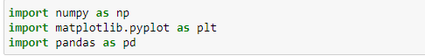

**Importing dataset**



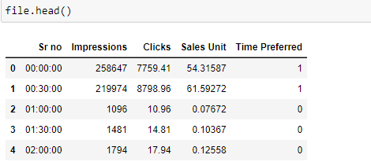

**Preprocessing the dataset**



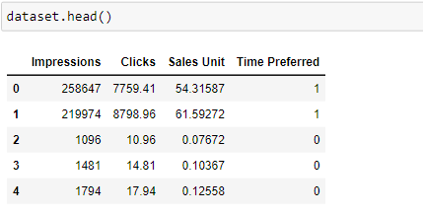



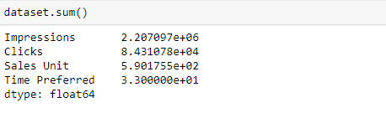

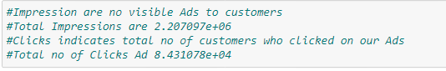





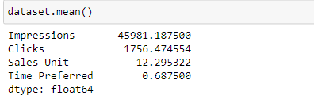

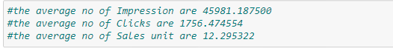

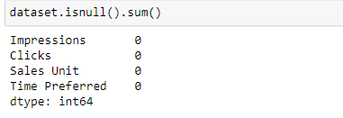



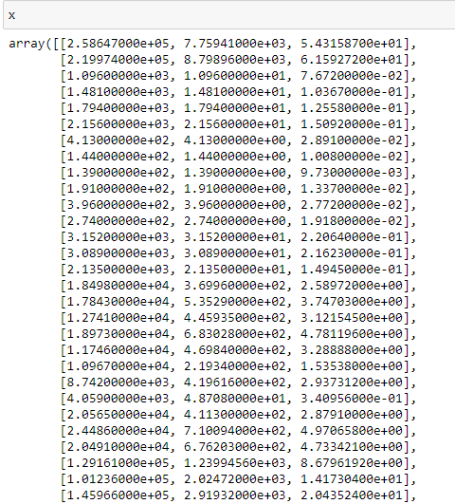

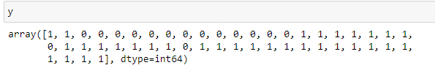

**Training the model**



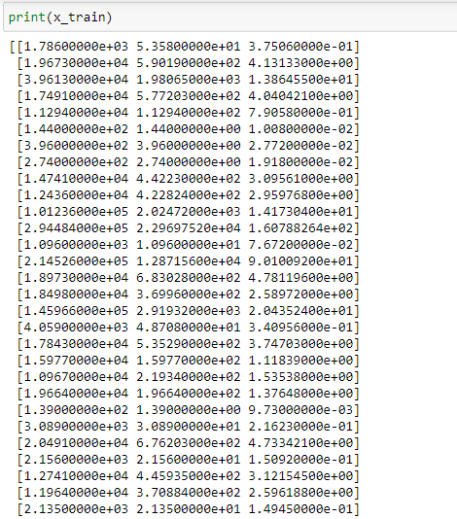

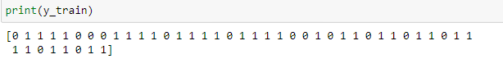

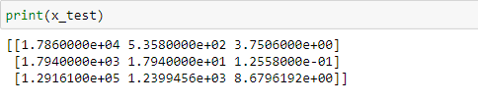

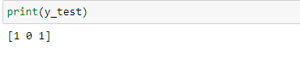

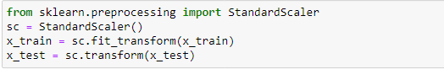

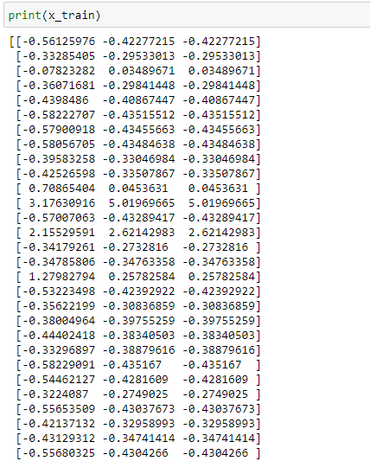

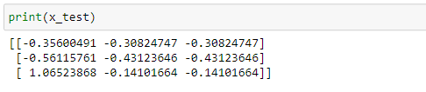

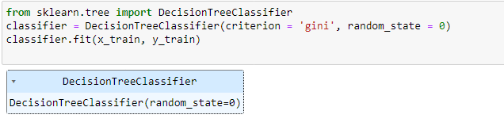

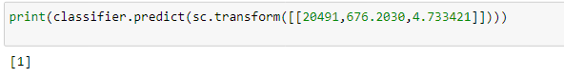

**Data Visualisation**

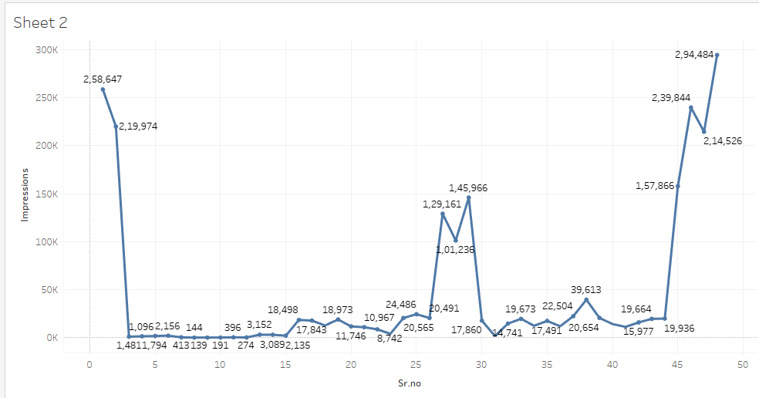

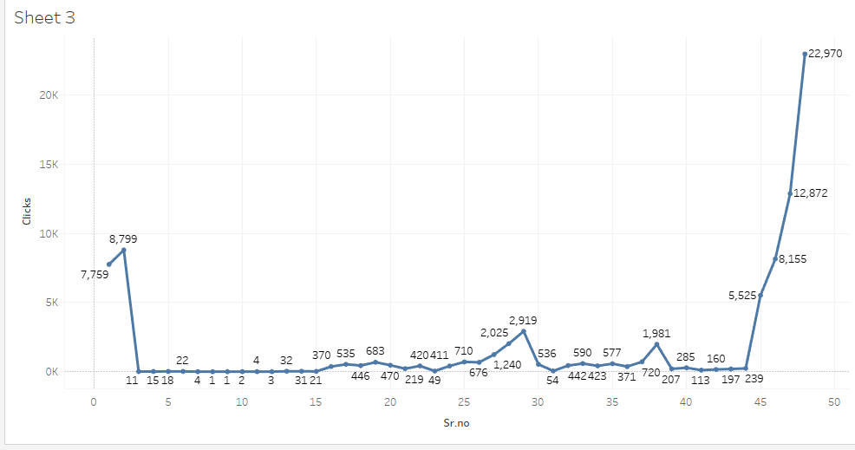

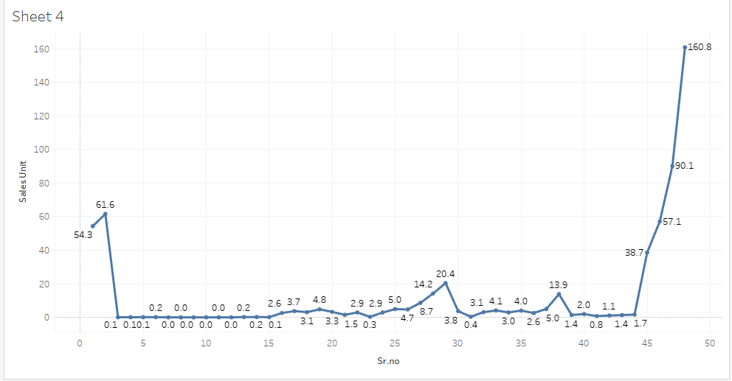

**Conclusion**



